Document Design and Graphics

Introduction
Document design is the process of choosing how to present all of the basic document elements so that our document's message can be clear and effective. When a document is well designed, readers understand the information more quickly and easily. Readers feel more positive about the topic and more accepting of its message. In other word, design documentation is a collection of documents and resources that covers all aspects of your product design. Documentation should include information about users, product features, and project deadlines; all essential implementation details; and design decisions that your team and stakeholders have agreed on.
Documents can be designed specifically as print publications ( newsletter, newspaper, brochure, or any handout) or as digital media. A PDF (Portable Document Format) can be both of these as it offers both print and on-screen viewing capabilities. Regardless of the form, the document development process remains the same. Document without a proper design is like the curry without salt. We might find the curry but without any taste. If documents are not properly designed, the readers may not be able to find out the information they are looking for. Obviously, use of words to represent the content is very important in writing but in terms of technical writing the appearance of words is also important. In order to make our readers pay their attention on the document, we(technical writers) need to have some expertise in designing our document in an attractive way.
Design-Elements
Besides text, it is important to consider some design elements in order to draw the readers' interest and clarify our documents. The main elements to consider when designing a document are white space, text, headings, graphics, and medium.
1. Text
Text is the words maintained in the document. There are different align-systems in word process. There are four different types of page arrangement. left justified, right justified, centre justified and left-right justified.
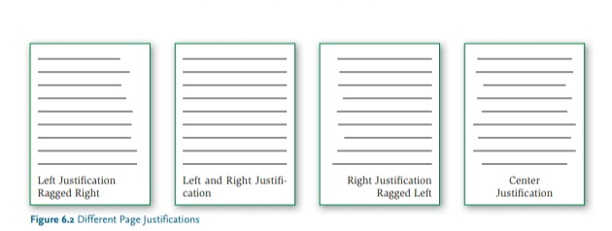
Moreover, font-type, the design and shape of letters, are divided into serif and sans serif. (Sans is French for “without.”) Serif refers to letters with distinguishing lines or “tails”, making it easy to see the differences between one letter and another. Sans serif refers to letters with few distinguishing lines and no “tails”. Serif fonts have that extra stroke or decorative design on the end of letters. Whereas Sans-Serif doesn’t have any such design or stroke.
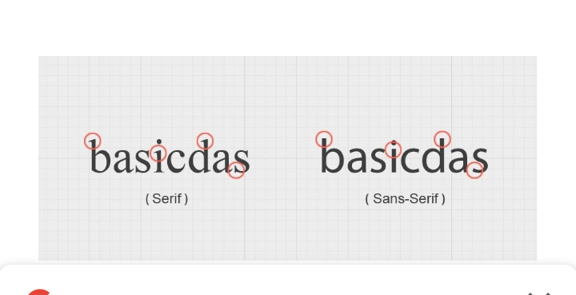
Serif typefaces are used in books, newspapers, and most magazines. Serif is a traditional/old typeface. some people say that they are more readable due to their serifs. It helps eyes moving from one letter to another. While Sans-Serif is called a modern typeface. Unlike Serif, they are more popular on computer screens. For example for websites, blogs, software, etc.

2. Use bold or bigger sized font to emphasize text
To show the importance of a word or parts of your text, use a bolder type weight or bigger sized text . However, bold text should be used for emphasis rather than being used consistently in the main body of the text.

3. Text should be set horizontally
Text at an angle or following a curved line can be more difficult to read. People should not have to rotate your document to read it.

4. Avoid splitting a word between two lines
Avoid splitting a word between the end of one line and the beginning of another as it disrupts the flow of the text. When using Microsoft Word, and similar programmes, this can be controlled by turning off the hyphenate function.
5. Headings
Headings are short titles that introduce the main idea of a selected portion of text. Like a formal outline, headings help your reader see the organization of a document in one glance. Most reports use a system of two headings (first-degree headings and second-degree headings).

6. Use a consistent and logical layout
Use a consistent layout for each section to make information easier to find for the user. Use recurring features; such as positioning headings, logos and page numbers in the same place in each section.
7. White Space
White space is space that is blank. It rests the eyes, separates chunks of information, and makes a document look inviting. Writers can create white space in margins, between paragraphs, before itemized lists, between columns, and around graphics.
8. Medium
Using the proper medium to publish the document is an important aspect of document design. Some possible means may be paper media (leaflet, advertisement, brochure and so on) or electronic media (internet, e-mail, CD-ROM, or web pages). The medium we choose depends upon the audience and purpose we have and the medium also matters the design of our document.
9. Graphics
Graphics are visual representations of objects, numbers, and other data in the form of pictures, diagrams, graphs and charts. The purpose of using graphics is to present information in a visual way and to clarify concepts such as location, size, relationship and comparisons. Graphics can increase interest and readability of documents for readers who might shy away from blocks of solid text. At present computers and graphics software programmes have helped a lot for a professional and polished look of any article or document.
Besides digitized images, writers create and insert a wide variety of graphics that supplement written materials. Graphs must be complete as well as accurate. Graphics add to our knowledge as well as entertain us. The main types of graphics used in technical writing are pictographs, line drawings, graphs, and tables. The purpose of adding graphics to technical report is to supplement the written materials. Graphics are not used to repeat information that is already clear to impress readers, nor are graphics used to lengthen a report. Effective graphics can clarify information, organize data, and emphasize important points. The measures of effective graphics are simplicity and usefulness.
In technical writing, graphics are often used to express the meaning of our document more clearly. Since visual presentation is more effective, some jargons and other difficult terminologies are clarified through graphics. sometimes, technical writers also use graphs along with the text and sometimes the graphics are presented independently.
Audience and Purpose of using graphics
Audience:
The audience of technical field focus more on the documents that have proper graphic presentation. And the readers wish to see graphic aids in the documents. However, readers vary in their ability to understand graphics. As with decisions about text and graphics depend on what your readers can understand and what they already know. Generally, the more data in a graphic, the more difficult it is to read. When deciding which graphic your audience will best understand, you should ask yourself these questions about your reader(s):
- How much does my reader know about the subject?
- How interested is my reader in the subject?
- Do my readers include a technical audience? In other words, do my readers need or expect technical information or figures?
- Will my audience be confused by technical information or figures?
- Does my audience’s reading level tend to be higher (tenth grade or higher) or lower (ninth grade or lower)?
Purpose and Objectives:
We need to think about using graphics on the basis of the wants and needs of our audience. Besides thinking about audience, the use of graphics also depends more on the purpose and objectives of our documents. The following can be the purposes in using graphics:
To present a small amount of numerical data-informal table
To present numbers in easy-to-read rows and columns-formal table
To explain an idea using words set up in rows and columns-verbal table
To contrast data and focus on differences-bar graph or pictograph
To contrast several sets of data and focus on the differences-double or multiple bar graph
To follow a trend over time-line graph
To compare several trends and show how data is related-double or multiple line graph
To show how the whole is divided into parts or how the parts relate to the whole-pie graph
To present a process-flowchart
To tell how to make a decision-decision flowchart
To present the structure of an organization-organizational flowchart
To present an idea using a symbol-icon
To show representative details of an object or a mechanism-diagram or line drawing
To show how something actually looks-photo
Designing Graphics
Graphic design is a craft where professionals create visual content to communicate messages. By applying visual hierarchy and page layout techniques, designers use typography and pictures to meet users’ specific needs and focus on the logic of displaying elements in interactive designs, to optimize the user experience.
- Keep Graphics Neat and Simple
Since graphics are presenting our document, they are supposed to be clear in form. A clear and clean graphic increases readability and can convey the intended meaning. Maintaining enough blank and space is also important while designing graphics.
b. Integrate Graphics with Text
Combining text with the graphics can clarify any confusion in the document. Generally, every graphic is interpreted for clarification. Text with graphic can also be helpful to the reader who is reading such graphic for the first time. It is important to use the word figure to refer to any graphic that is not a formal table. Draw your reader’s attention to figures or tables by incorporating references into your text. We can use the following parentheses and stand-alone sentences as follows:
- Table 1/Figure 1 shows the number of students who dropped their schools in 2018
- The number of female students who dropped their schools in 2018. (Table 1/Figure 1)
c. Use Colour Effectively
Colour creates ideas, expresses messages, sparks interest, and generates certain emotions. Some colours hold a universal significance- for example, it is commonly understood that red is a color for warning and green means 'go'. But, put together, most people would associate the color combination of red and green as Christmas. Bright colors tend to set a happy and positive mood, whereas dark colors tend to project the opposite. Within the psychology of colors, warm colors show excitement, optimism, and creativity; cool colors symbolize peace, calmness, and harmony.

- Indicate a document’s organization.
Colours can tell how our document is organized(made). For headings, we can use uniformed colour and for sub-heading, we can use another same colour. This will help our readers trace and understand the headings, sub-headings and other parts of our documents. Our readers can easily scan for important information.

- Emphasize or clarify an important point.
When using a color for a key word, a phrase, an idea, or part of a graphic, you draw your reader’s attention to important information. You also can use color to signify a change or to guide readers through a process.

- Support your text’s meaning.
Use of specific colour to denote a meaning will set our readers' mind on specific information. Once the mind is set, from every next time, our readers are connecting the colour with the meaning (red with danger, for example). This can help them understand the text more quickly.

- Make your document attractive.
We can make our document more attractive when we use proper colour combination. Using colors can make our document more eye-catching since that can break up black and white text.

Constructing Graphics
A. Constructing Tables
Tables give a systematic and orderly arrangement of items of information. Tabular layout has the particular virtue of juxtaposing items in two dimensions for easy comparison and contrast. Tables eliminate tedious repetition of words, phrases and sentence patterns that can instead be put at the tops of columns or at the sides of rows in the table. Although tables do not make much impact by visual display, it is possible, by careful arrangements, to emphasize and highlight particular items or groups of information. Tables can be organized with the information in numerical order, in alphabetical order or in an order which groups items according to common features or common values.
a. Informal Table
The table that shows the information in rows and columns without any row/column-heading and drawn lines. In this sort of table, the information is given in the form of text. The explanation of the graphic is a brief summary of the information presented in the graphic.
Concentration of calories in different food items
Egg-250
Meat-300
Rice-250
Pulse-300

b. Formal Table
This is exactly opposite to informal table since we can find an arrangement of information in rows and columns with rules (lines drawn). It is typically used to organize numbers, words, or other data in a consistent format. Formal table comes with proper headings in rows and columns. It generally requires footnotes and bibliographic information if taken from another source.
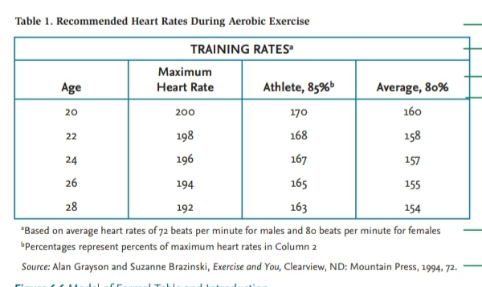
c. Verbal Table
A verbal table is similar to a word-chart. The framework is similar to a formal table however, it is unique in terms of the kinds of data included. Verbal tables use words instead of numeric expressions.
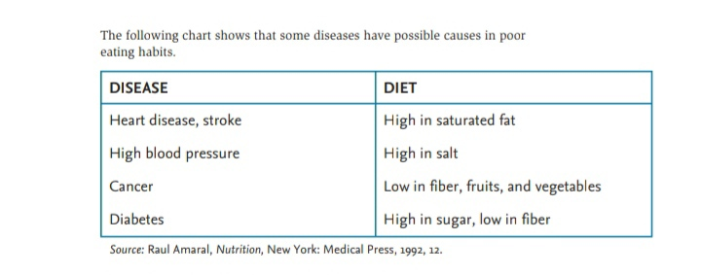
2. Constructing Graphs
Graphs include displays of numerical data using bars, lines, curves and circles. The purpose of graphs is to help the audience visualize the effects of a changed variable on a subject. The display often emphasizes a trend or illustrates the results of an experiment. The best graphs used are waveforms and exponential curves.
A. Bar Graph
A bar graph is also a visual representation of data (generally grouped), in the form of vertical or horizontal rectangular bars, where the length of bars are proportional to the measure of data. They are also known as bar charts. The bars drawn are of uniform width, and the variable quantity is represented on one of the axes. Also, the measure of the variable is depicted on the other axes. The heights or the lengths of the bars denote the value of the variable, and these graphs are also used to compare certain quantities.
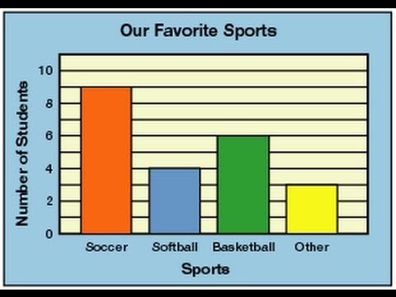
B. Multiple Bar Graph
Multiple bar graph is used to represent different value for more than one object that shares the same category. In this type of bar chart, the total number of instances are combined into a single bar. In other words, a multiple bar graph is a type of bar graph in which different sets of data items are compared. Here, a single color is used to represent the specific series across the set. The multiple bar graph can be represented using both vertical and horizontal bar charts.
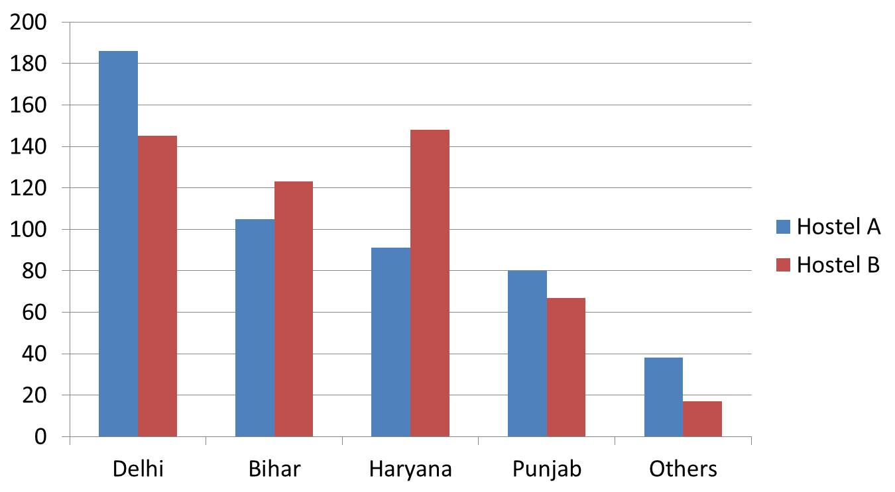

C. Line Graphs
Line graphs are made up of dots placed at coordinates according to fixed increments on the vertical and horizontal axes. The dots are then connected by straight lines or smooth curves to show the subject's response to changing conditions. The horizontal axis shows the changed condition, and the vertical axis represents the subject's response or activity. The line graph is similar to a bar graph in that it uses a horizontal axis and a vertical axis but there is difference as this graph uses a line.
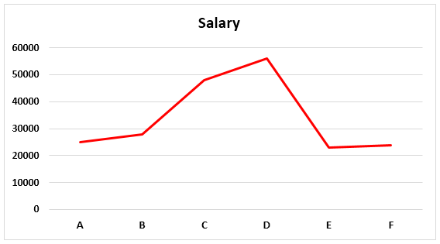

D. Multiple Line Graph
A multiple line graph shows the relationship between the values of multiple sets of data. Usually multiple line graphs are used to show trends over time. In this graph, each data value is represented by a point in the graph and later, the points are connected by a line. In a multiple line graph, there are two or more lines in the graph connecting two or more sets of data points. The independent variable is listed along the horizontal, or x, axis and the quantity or value of the data is listed along the vertical, or y, axis.
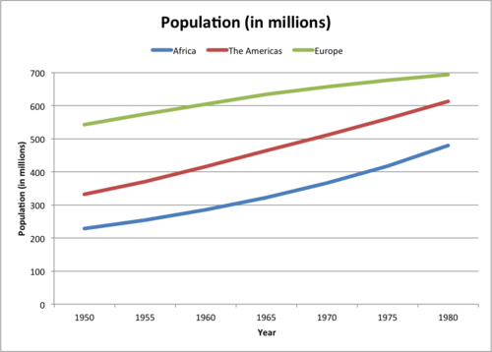
E. Pictograph
Pictograph is the depiction of pictures and images . The data are presented through pictures or images. A pictograph is a special kind of bar graph that uses pictures instead of bars to represent data. Pictographs add color and interest, are easy to read, and are especially appropriate for nonnative speakers of English. To be clear, the pictures or icons must be easily recognized and distinguishable from one another. This is one of the simplest ways to represent the statistics.
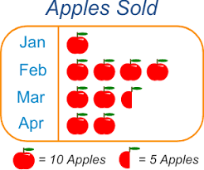

F. Pie Graphs
Pie charts are portioned circles in which each partition represents a percentage or proportion of the category. A pie chart displays data, information, and statistics in an easy-to-read 'pie-slice' format with varying slice sizes telling us how much of one data element exists. The main use of a pie chart is to show comparison. When items are presented on a pie chart, you can easily see which item is the most popular and which is the least popular.
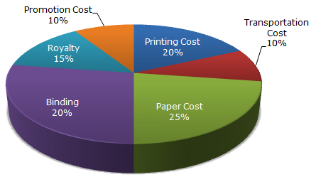

3. Constructing Charts, Diagrams, and Pictures
Chart generally include boxes, words, and lines to show a process or an organizational structure. Charts allow users to see the results of data to better understand and predict current and future data. Flowchart, decision flowchart, and organizational chart are the three most common charts used in data presentation.
A. Flowchart
A flowchart is representation of a process or how work flows in the form of graphics. Each step in the process is represented by a different symbol and contains a short description of the process step. The flow chart symbols are linked together with arrows showing the process flow direction. In a flowchart, the lines and arrows show a process or series of steps.
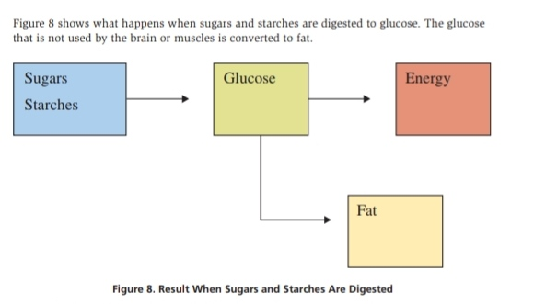

B. Decision Flowchart
A decision flowchart is a special flowchart that uses symbols to indicate critical parts of making a decision.

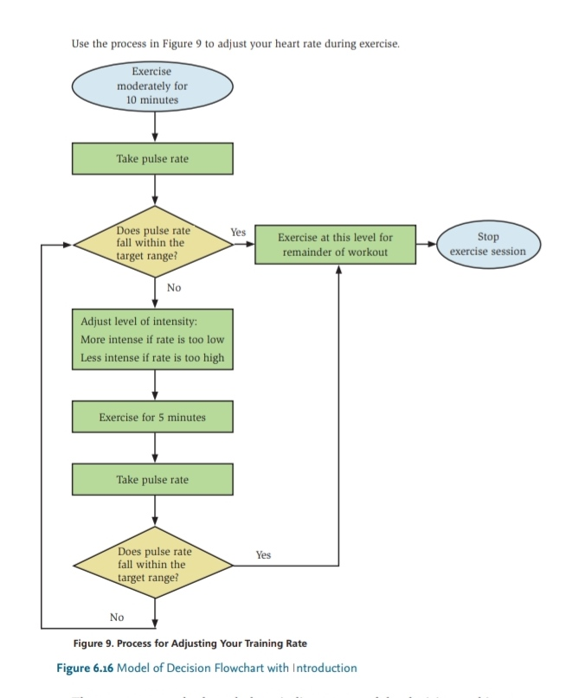
The figure uses the standard symbols to indicate parts of the decision-making process: Ovals indicate where the process starts and ends, rectangles or squares indicate activities, diamonds indicate places to make decisions, and arrows direct the flow of the process. The flow of information moves up and down and from left to right.

C. Organizational Chart
Organizational Charts are used to show the structure of an organization. The hierarchy is presented through this sort of chart. The highest position remains at the top and other posts in hierarchy are mentioned below.
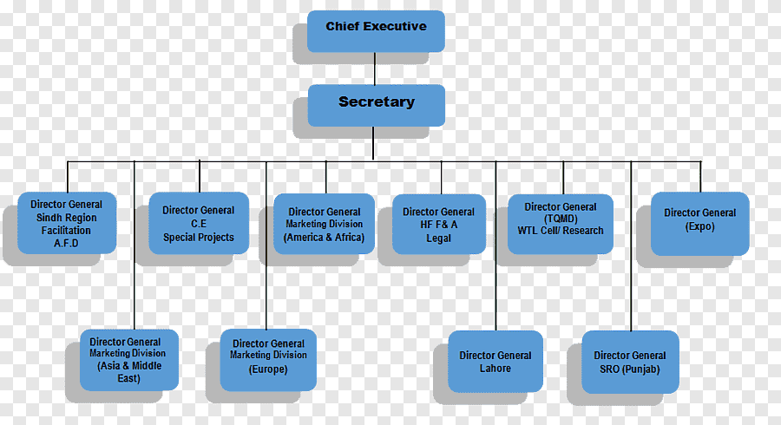

D. Gantt Chart
A Gantt chart, named after Henry Gantt, is a bar graph used to schedule the major tasks of a complex project. Gantt charts are used for planning projects of all sizes and they are a useful way of showing what work is scheduled to be done on a specific day. They also help you view the start and end dates of a project in one simple view.
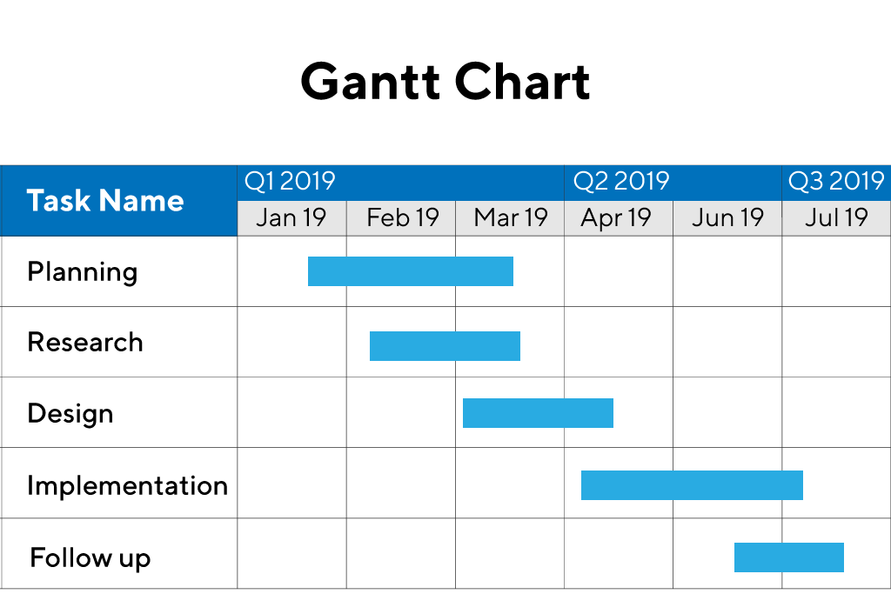
E. Diagram
A diagram is a visual form for presenting statistical data for highlighting the basic facts and relationship which are inherent in the data. The diagrammatic presentation is more understandable and it is appreciated by everyone. It attracts the attention and it is a quicker way of grasping the results saving the time. It is very much required, particularly, in presenting qualitative data.
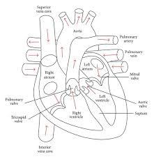

F. Icon
An icon is a picture/drawing -like presentation. An icon is a simple picture or drawing that represents an idea or a concept.

G. Photographs
Camera-produced graphics are easy to insert into reports using a scanner or digital reprints from negatives. Photographs include a great deal of detail, however, and are not always an appropriate graphic aid. Photos should be always clearly focused and include the intended object.

